SIMATS ENGINEERING (SAVEETHA SCHOOL OF ENGINEERING)
Department of Computer Science and Engineering

ASSESSMENT TOOL 3 – DEBUGGING & OPTIMISATION TASK
Course Code: | CSA06 | Course Title: | Design and Analysis of Algorithms
CO Assessed: | CO2 – Manipulation (BL1, BL2, BL3) | Assessment: | Assessment Tool 3 – Debugging &  Optimisation Task
Weightage: | 10% of CIA | Total Marks: | 100
CO2 Statement: | Apply Brute Force technique to solve sorting, searching, Closest-Pair and Convex-Hull problems  (BL1, BL2, BL3)
Student Name: | C.Manogna sri hasitha | Reg. No.: | 192525215
Section / Batch: | B-Tech AI&ML | Date: | 16-07-2026

Instructions to Students
- Answer the following question. Total Marks: 100.
- Carefully analyze the given program/code segment before identifying errors.
- Clearly identify logical, syntactical, and performance-related issues in the code.
- Apply systematic debugging techniques to correct the errors effectively.
- Optimize the given solution by improving efficiency, reducing unnecessary computations, or enhancing time complexity wherever possible.
- Provide proper justification for all corrections and optimization decisions.
- Write clean, structured, and well-documented code with appropriate comments.
- Maintain clarity, logical reasoning, and technical accuracy throughout the solution.

Question Type | Focus Area | Questions
Debugging &  Optimisation Task | Identify errors, debug programs, and optimize algorithm efficiency using appropriate techniques | Q1

SECTION A – DEBUGGING & OPTIMISATION TASK

Code of Conduct
I __C.Manogna sri hasitha__ (Name / Reg No) certify that this submission is my original work and that I have adhered to the guidelines specified for this assessment. I understand that any violation of academic integrity rules will result in disciplinary action.
Signature of the Student: __C.Manogna sri hasitha____

RUBRICS FOR CALCULATION

Criteria | Wt. | Level 4 – Exemplary | Level 3 –  Proficient | Level 2 –  Developing | Level 1 –  Beginning
Problem  Identification | 20% | Accurately identifies all errors and root causes with clear understanding | Identifies most errors with minor gaps | Identifies some errors but misses key issues | Unable to identify errors correctly
Debugging | 25% | Applies systematic debugging techniques effectively to resolve issues | Uses appropriate debugging methods with minor errors | Limited debugging approach; requires guidance | Unable to debug or resolve issues
Optimization | 20% | Optimizes code by significantly improving time complexity using efficient algorithms | Improves time complexity with minor gaps in efficiency | Limited improvement in time complexity | No improvement;  inefficient approach retained
Analysis | 20% | Demonstrates strong logical reasoning and clear justification of solutions | Shows reasonable  analysis with some justification | Limited analysis; weak reasoning | No analytical reasoning demonstrated
Code Quality | 15% | Produces clean, wellstructured code with proper comments and documentation | Code is mostly clear with minor documentation gaps | Code lacks structure and proper documentation | Poorly written code with no documentation

Marks Evaluation:
Criteria |  | Wt. | Level 4 –  Exemplary | Level 3 –  Proficient | Level 2 –  Developing | Level 1 –  Beginning
Problem Identification |  | 20%
Debugging |  | 25%
Optimization |  | 20%
Analysis |  | 20%
Code Quality |  | 15%
Total Marks (100):

Faculty In-charge | Course Coordinator | Head of Department
Name: | Name: | Name:
Signature: _______________ | Signature: _______________ | Signature: _______________
Date: ___________________ | Date: ___________________ | Date: ___________________

Q1 | Debugging Linear Search Code (Incorrect Loop Starting Index)  The following Linear Search implementation begins checking from the wrong index and may skip a valid match at the start of the array. Carefully analyze the loop initialization and explain why the first element is ignored. Apply debugging to ensure that every element from the beginning of the array is checked correctly. Optimize the implementation for simplicity and readability while preserving correct functionality. Analyze the time complexity of the corrected version and rewrite the final code with proper comments.  def linear_search(arr, key):  for i in range(1, len(arr)): # ERROR  if arr[i] == key:  return i  return -1

Q1 . Debugging Linear Search Code: Correcting the Loop Initialization and Ensuring Complete Array Traversal

Introduction
Linear Search is one of the simplest searching algorithms used to locate an element in an array or list. It works by checking each element sequentially from the beginning until the target element is found or the end of the array is reached. Because it examines every element one by one, Linear Search works on both sorted and unsorted data.
In the given implementation, the search loop incorrectly starts from index 1 instead of index 0. As a result, the algorithm completely skips the first element of the array. If the target value is stored at the first position, the algorithm incorrectly reports that the element is not found.
The objective of this assignment is to analyze the bug, explain why it occurs, correct the implementation, optimize the code for readability, and evaluate the time complexity of the corrected algorithm.

Given Code

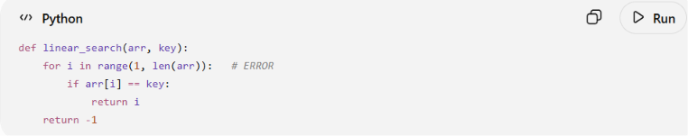

Problem Analysis
The error lies in the loop initialization:

Why the First Element Is Ignored

The range() function generates values starting from its first argument.
range(1, len(arr))
produces:
1, 2, 3, ..., len(arr)-1
Notice that 0 is missing.
Therefore, the first element is skipped completely.

Example of Incorrect Execution
Suppose:
arr = [10, 20, 30, 40, 50]
key = 10
Execution:
Iteration | Index Checked | Value | Match?
1 | 1 | 20 | No
2 | 2 | 30 | No
3 | 3 | 40 | No
4 | 4 | 50 | No
The first element (10) is never checked.
Output:
-1
This result is incorrect.

Debugging the Algorithm
To fix the problem, the search should begin from index 0.
Correct loop:
for i in range(len(arr)):
Now every element is checked.

Corrected Algorithm
Step 1
Start from the first element.
Step 2
Compare each element with the key.
Step 3
If a match is found, return its index.
Step 4
If the loop finishes without finding the key, return -1.

Optimized Python Code
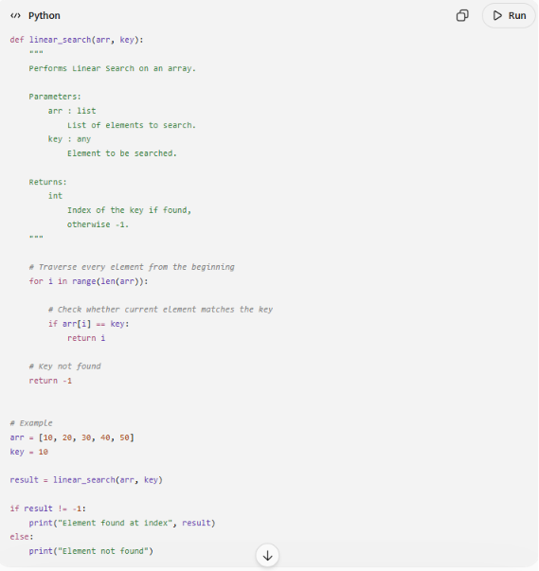
Simpler Python Version
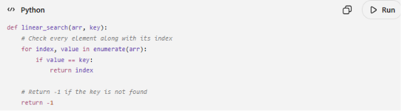

Dry Run of the Corrected Algorithm
Example:
arr = [10, 20, 30, 40, 50]
key = 10
Iteration | Index | Value | Match
1 | 0 | 10 | ✔ Yes
Output:
0
The algorithm correctly identifies the first element.

Flowchart of the Corrected Algorithm
Start
│
▼
Input Array and Key
│
▼
Set i = 0
│
▼
Is i < length of array?
│
┌─┴──────────┐
│ │
No Yes
│ │
▼ ▼
Return -1 Compare arr[i] with key
│
┌───────┴────────┐
│ │
Equal Not Equal
│ │
▼ ▼
Return Index i = i + 1
│ │
└──────► Repeat

Time Complexity Analysis
Let n be the number of elements in the array.
Best Case
The key is found at the first position.
- Comparisons: 1
- Time Complexity: O(1)

Average Case
The key is found somewhere in the middle.
- Comparisons: n / 2
- Time Complexity: O(n)

Worst Case
The key is at the last position or does not exist.
- Comparisons: n
- Time Complexity: O(n)

Space Complexity
The algorithm uses only one loop variable.
Space Complexity: O(1)

Comparison of Incorrect and Correct Versions
Feature | Incorrect Version | Correct Version
Starting Index | 1 | 0
Checks First Element | No | Yes
Correct Results | Not Always | Yes
Time Complexity | O(n) | O(n)
Space Complexity | O(1) | O(1)
Readability | Lower | Higher

Advantages of the Corrected Algorithm
- Checks every element from the beginning of the array.
- Correctly finds elements located at index 0.
- Works with both sorted and unsorted arrays.
- Simple to implement and understand.
- Uses constant extra memory.
- Suitable for small datasets.

Conclusion
The original Linear Search implementation contained a logical error because the loop started at index 1, causing the first element of the array to be ignored. Since Python arrays use zero-based indexing, the search must begin at index 0 to ensure that every element is examined. After correcting the loop initialization, the algorithm functions correctly and returns the appropriate index whenever the target element is found. An optimized version using enumerate() further improves readability without changing the algorithm's behavior. The corrected Linear Search algorithm has a best-case time complexity of O(1), an average-case and worst-case time complexity of O(n), and a space complexity of O(1), making it a simple and reliable choice for searching in small or unsorted datasets.

